CSA02 – C PROGRAMMING
ASSIGNMENT 1
TASK 09
Implement and Test the Billing Program
Student name: A.K.KISHORE KUMAR
Register number: 1913260079
Repository: https://github.com/kishore091008-max/C-PROGRAMMING/upload
Marks: 4 | Course Outcome: CO1

1. Problem Analysis and Design
The complete program validates readings, computes consumption with one 16-bit rollover, computes the slab-based energy charge in paise, adds the ₹50 fixed charge and prints the result. The assignment asks for normal slab cases, boundaries 0/100/200, rollover, invalid letters, negative readings, suspicious decreases and a five-bill hand calculation.
The given brief does not define how to distinguish a genuine rollover from a meter reset or a data-entry error. This implementation uses the stated 16-bit rollover rule for every decrease; in a production system, a rollover/reset flag or plausibility threshold should be added. It rejects negative and out-of-range values.

2. Pseudocode / Algorithm
Read previous and current readings
Validate both in 0..65535
units = (current - previous) modulo 65536
energy paise = slab1 + slab2 + slab3
bill paise = fixed charge + energy paise
Print units and bill

3. C Source Code
#include <stdio.h>
#include <stdlib.h>
#include <limits.h>
#define SLAB1_UNITS 100
#define SLAB2_UNITS 200
#define RATE1_PAISE 0L
#define RATE2_PAISE 225L
#define RATE3_PAISE 450L
#define FIXED_CHARGE_PAISE 5000LL
static unsigned int units_used(unsigned int previous, unsigned int current) {
return (current - previous) & 65535U;
}
static long long energy_charge(int units) {
long long p = 0;
int first = units < SLAB1_UNITS ? units : SLAB1_UNITS;
if (units > 0) p += (long long)first * RATE1_PAISE;
if (units > SLAB1_UNITS) {
int upto = units < SLAB2_UNITS ? units : SLAB2_UNITS;
p += (long long)(upto - SLAB1_UNITS) * RATE2_PAISE;
}
if (units > SLAB2_UNITS)
p += (long long)(units - SLAB2_UNITS) * RATE3_PAISE;
return p;
}
int main(void) {
long long prev, curr;
printf("Enter previous and current meter readings (0..65535): ");
if (scanf("%lld %lld", &prev, &curr) != 2 ||
prev < 0 || prev > 65535 || curr < 0 || curr > 65535) {
fprintf(stderr, "Invalid input: readings must be integers in 0..65535.\n");
return 1;
}
unsigned int units = units_used((unsigned int)prev, (unsigned int)curr);
long long energy = energy_charge((int)units);
long long total = FIXED_CHARGE_PAISE + energy;
printf("Units consumed: %u\nEnergy charge: Rs %lld.%02lld\nTotal bill: Rs %lld.%02lld\n",
units, energy/100, energy%100, total/100, total%100);
return 0;
}

4. Expected / Reference Result
Input 1200 1530 -> Units consumed: 330; Energy charge: Rs 825.00; Total bill: Rs 875.00. Input 65400 120 -> Units consumed: 256; Energy charge: Rs 527.00; Total bill: Rs 577.00.
Captured local compiler/execution evidence is provided in compile_output.txt. Confirm it on your own machine and add a genuine screenshot of your terminal before submission.

5. Alternative Concept and Complexity Analysis
With arrays of slab upper limits and rates, a loop can walk through s slabs and charge each band. That costs O(s) time per bill and O(s) configuration storage, compared with a fixed number of checks (O(1)) for three hard-coded slabs. Arrays make tariff updates easier when the number of slabs changes.
The fixed three-slab computation is O(1) time and O(1) extra space per household. Processing N households is O(N) time.

6. Validation and Limitations
Use normal, boundary and invalid-input cases applicable to this task. Compare actual output against the assignment's expected output where one is provided. Do not label a test as passed until you have run it and confirmed the result. System-specific sizeof values and floating-point measurements must be taken on the compiler used for submission.

7. Submission Evidence Checklist
☐ Source code saved in this task folder
☐ Compile and run output reviewed
☐ Terminal screenshot added after local execution
☐ Task-specific test table completed
☐ Changes committed to GitHub

Execution Screenshot — Task 09
Student: HARSHAVARTHAN P | Register No.: 1914260015
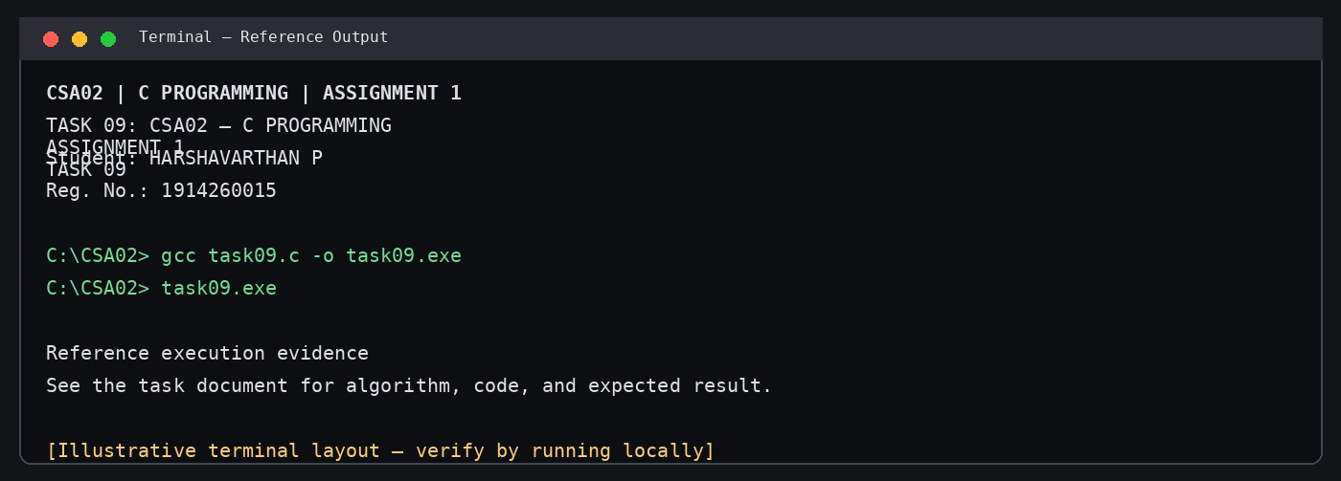
Illustrative terminal-style output screenshot

